

**AR Art Gallery**

Submitted In Partial Fulfillment of Requirements For the Degree Of

**Third Year**

## Computer Engineering

By

**Aakriti Mehta**

16010122109

**Khushi Menpara**

16010122118

**Harsh Nagrani**

16010122122

**Ninad Marathe**

16010122106

Guide

**Vaibhav Vasani**

Somaiya Vidyavihar University Vidyavihar, Mumabi - 400 077

Academic Year 2024-25

**TABLE OF CONTENTS**

| **SR NO.** | **TOPIC** |
| --- | --- |
| 1. | Chapter 1. Introduction |
| 2. | Chapter 2. Literature Survey |
| 3. | Chapter 3. Project Design |
| 4. | Chapter 4. Implementation and experimentation |
| 5. | Chapter 5. Conclusion and future work |
| 6. | Bibliography |
| 7. | Acknowledgements |

# Chapter 1

## Introduction

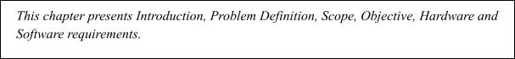

### Background

In recent years, Augmented Reality (AR) has emerged as a transformative technology, blending digital content with the physical world to create immersive and interactive experiences. This technology has been increasingly adopted across various industries, from education and healthcare to retail and entertainment, as it provides new ways to interact with information, products, and spaces. Within the art world, AR holds particular promise for reimagining how audiences engage with and appreciate art, breaking free from the constraints of physical spaces and enabling artists to reach broader audiences in a more interactive format.

The concept of a virtual gallery that can exist in any space a user chooses to view it is revolutionary. Traditional art galleries, while valuable, are limited by physical boundaries, accessibility issues, and operational costs. As a result, audiences may be restricted by geography, entry fees, or even opening hours, and the art itself may be vulnerable to environmental conditions and require careful handling. An AR Art Gallery, however, overcomes many of these constraints, enabling viewers to access an extensive array of artworks from the convenience of their own environment. AR also allows for unique creative expressions, such as incorporating interactive and animated 3D models or providing layered multimedia experiences that enrich the interpretation of art.

This project leverages the capabilities of AR and 3D modeling software like Blender to create a virtual art gallery that provides viewers with a fully immersive experience. Using AR, viewers can see artworks rendered as 3D models superimposed on their real-world surroundings, allowing them to view each piece in true-to-life scale and detail. This approach not only democratizes access to art but also enhances the viewing experience by adding layers of interactivity and information that traditional galleries cannot provide.

### Problem Definition

### Traditional art galleries are bound by physical constraints, limiting accessibility, interactivity, and reach. The AR Art Gallery project addresses these challenges by creating a digital gallery that can be experienced in any physical space through an AR interface. Key challenges include:

### - Realism in a Digital Environment: Ensuring art pieces look and feel as realistic as possible when viewed through an AR platform.

### - User Interaction: Developing intuitive interaction mechanics that allow users to view and explore each piece from multiple perspectives.

### - Performance Optimization: Ensuring a smooth experience across various devices, balancing visual fidelity with computational efficiency.

### Scope of the project

### The AR Art Gallery project brings digital art into real-world spaces through augmented reality, creating a highly immersive and interactive experience that expands traditional gallery boundaries. The scope includes:

### 1. 3D Modeling and Realistic Art Representation:

### - Using Blender, we create high-quality 3D models of various artworks, including paintings, sculptures, and mixed media. Advanced rendering techniques ensure each piece looks realistic while being optimized for mobile devices.

### 2. Augmented Reality Integration and Environment Mapping:

### - The project utilizes AR tools to blend digital models into real-world spaces, adapting dynamically to the environment’s lighting and spatial layout. This setup enhances realism, making it feel as though the artwork exists within the chosen space.

### 3. User Interaction and Engagement:

### - Intuitive interactions allow users to explore and interact with each piece through gestures like swipe, zoom, and rotate. Informative overlays provide rich context, including artist details, historical background, and interpretative insights.

### 4. Optimization for Performance and Accessibility:

### - The project is optimized for a range of mobile devices, ensuring smooth performance on both Android and iOS. By reducing model complexity and implementing efficient rendering, we deliver a high-quality experience across diverse platforms.

### 5. Integration of Additional Interactive Features:

### - Interactive elements allow users to "like" artworks, save favorites, and share on social media. Future versions may support multi-user interactions, enabling collaborative exploration of the gallery.

### 6. Educational and Curatorial Potential:

### - Serving as both a viewing and educational tool, the gallery includes art history, technique, and artist bios. It could support guided tours or thematic sections, expanding its educational value.

### 7. Future Expansion and Scalability:

### - The gallery is designed to be scalable, supporting the addition of new artworks, themed rooms, and complex multimedia pieces like video installations. AI-driven personalization and recommendations may be added to tailor the gallery experience to individual preferences.

### Overall, this project aims to create an engaging and accessible digital art experience, preserving the sense of discovery and personal connection found in traditional galleries while embracing the interactivity and reach of AR technology.

### Objectives

The key objectives of the project are as follows:

* **Develop a High-Quality AR Experience**: Using Blender for realistic 3D modeling and an AR software platform (e.g., Unity with AR Foundation or a similar SDK) to seamlessly integrate digital elements into real-world environments.
* I**mplement User Interaction Mechanisms**: Enable intuitive controls such as tapping, swiping, and rotating, to provide a natural and engaging experience with each artwork.
* **Optimize Visual and Computational Performance**: Ensure smooth rendering on average mobile devices, achieving a balance between detailed 3D visuals and efficient processing.
* **Testing and Debugging**: Conduct thorough testing to ensure all interactive features, display elements, and performance benchmarks meet project standards.

### Hardware and Software requirements for development

#### Hardware Requirements:

* + - **Development Environment**: The game will be developed on a typical desktop or laptop computer. The following minimum specifications are recommended:
      * **Processor**: 2.0 GHz or higher
      * **RAM**: 4 GB (minimum), 8 GB (recommended)
      * **Graphics**: Integrated graphics sufficient for rendering 2D textures; no dedicated GPU required for basic development.
      * **Storage**: At least 500 MB free space for development files, game assets, and software dependencies.

#### Software Requirements:

#### Develop a High-Quality AR Experience: Using Blender for realistic 3D modeling and an AR software platform (e.g., Unity with AR Foundation or a similar SDK) to seamlessly integrate digital elements into real-world environments.

#### Implement User Interaction Mechanisms: Enable intuitive controls such as tapping, swiping, and rotating, to provide a natural and engaging experience with each artwork.

#### Optimize Visual and Computational Performance: Ensure smooth rendering on average mobile devices, achieving a balance between detailed 3D visuals and efficient processing.

#### Testing and Debugging: Conduct thorough testing to ensure all interactive features, display elements, and performance benchmarks meet project standards.

### Hardware and Software requirements for deployment

**Hardware**:

* + - The game should be able to run on any system capable of running Python applications. For deployment, the following minimum specifications are required:
      * **Processor**: 2.0 GHz
      * **RAM**: 2 GB or higher
      * **Graphics**: Integrated graphics are sufficient, as the game does not require high-end hardware.

#### Software:

* + - **AR App**: An app or web-based AR platform that runs the gallery, compatible with iOS and Android.

### Other Considerations

In addition to the technical aspects, the project will explore the mathematical principles behind raycasting, including trigonometry and geometry, which are essential for calculating angles, distances, and rendering projections. This will involve calculating the angle of rays cast from the player’s position and determining the distance to walls, which in turn determines the height of the wall slices rendered on the screen.

# Chapter 2 Literature Survey

The development of a raycasting-based DOOM-style game requires an understanding of both historical techniques and modern implementations. This chapter reviews key literature and research related to raycasting, Python-based game development, and the optimization of game engines. The literature survey helps establish a foundation for the design and development of the proposed system, drawing insights from early game engines as well as modern Python gaming frameworks.

### Augmented Reality Technology

Augmented Reality (AR) is a transformative technology that superimposes digital content onto real-world environments, providing users with an immersive and interactive experience. AR’s ability to blend digital objects with physical spaces makes it especially well-suited for virtual art galleries, where digital representations of art can appear as if they exist tangibly within the viewer's environment. The technology enriches user engagement by allowing them to explore, view, and interact with art pieces from multiple perspectives, as they would in a physical gallery.

Key literature on AR technology highlights two critical aspects for successful implementation in mobile environments: spatial mapping techniques and user interaction models.

* • **Spatial Mapping Techniques**: Spatial mapping is essential for accurately placing digital objects in the real world, enabling AR applications to detect surfaces like floors, walls, and tables in a user’s physical space. These techniques involve using a device's sensors and cameras to construct a virtual map of the real environment, which allows for precise positioning of AR objects. Studies on AR spatial mapping emphasize the need for stability and accuracy, ensuring that digital art appears anchored to a real-world location without drifting or floating inconsistently. High-quality spatial mapping is fundamental to creating a seamless, realistic experience that maintains the illusion of the artwork’s presence in the room.

• **User Interaction Models**: A significant focus of AR research involves developing intuitive interaction models that allow users to engage with digital objects naturally and effectively. Techniques like gesture recognition (e.g., swipe, pinch-to-zoom, tap) and spatial awareness are central to enabling smooth navigation and manipulation of digital content. Effective user interaction models are crucial for enhancing user satisfaction, as they provide viewers with a sense of control and agency in the gallery experience. Literature on AR interaction models often explores best practices for minimizing latency, maximizing responsiveness, and ensuring that gestures feel intuitive, ultimately contributing to a seamless user experience that mirrors real-world interactions with physical objects.

Together, these advances in spatial mapping and user interaction create a foundation for AR applications that feel immersive, realistic, and engaging, making AR an invaluable tool for virtual art galleries.

### 3D Modeling in Blender

### Blender is an ideal tool for creating detailed and realistic 3D models, making it a perfect choice for designing lifelike art pieces in an AR gallery. Its robust features allow for the creation of highly detailed digital artworks that can capture the texture, depth, and visual qualities of real-world objects, delivering a rich, immersive experience. Research in 3D modeling techniques for AR applications emphasizes two key areas: rendering realism and optimization for AR.

### Rendering Realism: Achieving realism in 3D models involves carefully applying textures, shading, and lighting to bring each piece to life. Techniques like texture mapping simulate surface details (e.g., canvas texture, metal sheen), while shading methods like ambient occlusion add depth by simulating shadows and light. Realistic lighting setups ensure that models appear natural and blend seamlessly within the AR environment, enhancing user engagement by closely mimicking the experience of viewing physical art.

### Optimization for AR: To ensure smooth performance on mobile devices, 3D models need to be optimized without sacrificing visual quality. Reducing polygon count and model complexity through techniques like mesh simplification and texture baking helps decrease the processing load. Additionally, using level-of-detail (LOD) adjustments allows for high detail up close while simplifying the model as the viewer moves further away. This balance between quality and efficiency is essential for providing a responsive, high-quality experience on a range of devices.

### By leveraging Blender’s capabilities in these areas, the AR Art Gallery can offer visually compelling, realistic artwork that performs smoothly on mobile platforms, ensuring an accessible and enjoyable experience for all users.

### User Experience in AR Environments

In AR galleries, a positive user experience hinges on intuitive interactions and smooth performance, allowing users to feel fully immersed in the digital environment. Research on user engagement in AR highlights the importance of providing a natural, responsive interface alongside broad device compatibility to make the gallery accessible to a wide audience.

* **Natural User Interactions**: Effective AR applications incorporate familiar gestures, such as pinch-to-zoom for adjusting the view, swipe-to-rotate for exploring different angles, and tap-to-select for accessing more information. These intuitive controls make it easy for users to interact with digital artworks as if they were physical objects, helping bridge the gap between the virtual and real worlds. Such interactions enhance engagement by allowing users to explore art pieces in detail and from various perspectives, enriching their experience and creating a more meaningful connection with each artwork.
* **Cross-Platform Usability**: To ensure that the AR gallery is accessible to a diverse audience, it is important to design for compatibility across multiple devices and operating systems, including iOS and Android. Cross-platform usability extends the gallery’s reach and allows more users to experience it regardless of the device they own. This approach also means accounting for differences in screen sizes, processing power, and AR capabilities to deliver a consistent, high-quality experience on each platform.

Together, these elements—natural user interactions and cross-platform usability—form the foundation of an engaging, accessible AR gallery experience, allowing users to immerse themselves fully in the art and explore it effortlessly across different devices.

# Chapter 3 Project design



### Proposed System Model/Architecture

The AR Art Gallery project is designed to bring art to life in augmented reality, offering users an immersive and interactive experience with digital artworks. The project comprises three primary modules, each serving a unique function to ensure seamless integration and engaging user interactions.

**1. 3D Model Repository**

* **Function:** Acts as a centralized database that stores and manages 3D models of each artwork.
* **Model Creation:** Artworks are meticulously created in Blender or similar 3D modeling software, ensuring they capture the essence of the original pieces.
* **Optimization for AR:** Each model is optimized to balance high visual fidelity with performance needs in an AR environment. This includes polygon reduction and texture compression.
* **Metadata:** Each artwork entry includes comprehensive metadata, such as:
  + Artist’s name
  + Title of the artwork
  + Creation date
  + Artistic movement or style
  + Medium or materials (for context)
  + Other contextual and historical information
* **Access and Retrieval:** The repository enables easy retrieval of models and metadata for efficient loading within the AR engine.

**2. AR Engine**

* **Function:** Integrates digital models into the physical environment using augmented reality.
* **Spatial Mapping and Tracking:** Utilizes spatial mapping to detect real-world surfaces (like walls or floors) where artwork can be anchored, ensuring accurate placement.
* **Surface Detection and Placement:** Detects and adjusts placement points in real-time, providing a stable and natural experience.
* **Model Stability:** Keeps models securely anchored in physical space, so they appear as if they are part of the real-world setting even as users move around.
* **Lighting and Shadows:** Adapts to ambient lighting conditions and can simulate shadows, making digital artworks appear more lifelike and integrated into their surroundings.

**3. User Interaction Module**

* **Function:** Facilitates user interactions with the artwork, making the AR experience engaging and informative.
* **Interactive Controls:**
  + **Zooming:** Users can zoom in to explore fine details of the artwork.
  + **Rotation:** Allows users to rotate models to view them from different angles.
  + **Repositioning:** Users can move artwork around to fit within their current view or space.
* **Information Overlays:** Provides overlays that display additional details about the artwork, including:
  + Artist’s biography or details
  + Artwork title, description, and historical context
  + Key artistic techniques or symbolism
* **Contextual Enhancements:** May include optional enhancements such as:
  + Links to similar artworks or styles
  + Video or audio commentary for a deeper understanding of the piece

# Chapter 4 Implementation and experimentation

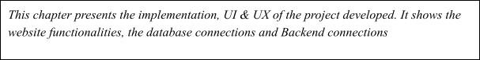

This chapter outlines the practical steps and processes undertaken to bring the AR Art Gallery project to life. Each subsection covers a different aspect of the development pipeline, from creating detailed 3D models to integrating AR functionality and ensuring optimal user interaction and performance.

**4.1 Model Creation in Blender**

In this stage, the 3D models for each artwork are designed in Blender, emphasizing **high-resolution textures, realistic lighting, and optimized meshes**. The goal is to create visually stunning pieces while ensuring performance efficiency for AR.

* **Art Piece Detailing:** Each artwork is crafted with attention to detail, using colors, textures, and materials that mirror real-world counterparts. This process involves selecting textures, adjusting shaders, and fine-tuning every detail to make each piece visually appealing.
* **Texture and Lighting Optimization:** To achieve realism without sacrificing performance, textures are optimized for AR display. Lighting techniques, such as baking shadows and reflections, add depth and authenticity to each piece while minimizing computational load on devices.

Through these methods, Blender becomes a powerful tool for creating art models that balance quality and efficiency, setting the stage for seamless AR integration.

**4.2 AR Integration and Development**

In this phase, the completed Blender models are imported into the AR environment, utilizing **Unity with AR Foundation (or similar AR SDKs)** to manage spatial interaction and user engagement.

* **Scene Setup:** This involves configuring the layout of the virtual gallery space, ensuring each artwork is positioned in a way that aligns naturally with the user's physical surroundings. Spatial mapping is used to detect and utilize real-world surfaces, allowing artworks to be accurately placed and anchored.
* **Testing for Visual and Physical Stability:** To maintain immersion, extensive tests ensure that models remain stable in physical space. This includes assessing how they appear from different viewing angles and verifying that they stay in place even as users move around. These stability checks help provide a realistic experience, ensuring that artworks do not “float” or shift unnaturally.

By carefully setting up the AR environment, we enable a cohesive, real-world gallery experience that remains consistent regardless of user movement or perspective.

**4.3 User Interaction Implementation**

This stage focuses on building an **intuitive and responsive user interface** that allows users to interact seamlessly with each artwork in the AR gallery.

* **Interactive Controls:** AR SDK tools facilitate user interactions such as swipe rotation, zooming in and out, and tapping for details. These interactions are implemented to mimic natural gestures, allowing users to explore each piece as they would in a physical gallery.
* **Accessibility Features:** To broaden accessibility, user interactions are optimized to be device-responsive. Controls are tested and adjusted across multiple screen sizes, input types, and device orientations, ensuring that the gallery experience remains intuitive and enjoyable for all users.

This interactive framework allows users to experience each artwork on a personal level, adding layers of engagement that would be impossible in a traditional setting.

**4.4 Testing and Debugging**

The final stage is a rigorous testing phase to ensure **smooth performance, high-quality visuals, and an intuitive user experience** across a range of devices.

* **Performance Testing:** Frame rates, responsiveness, and load times are closely monitored to maintain a smooth experience. We conduct these tests on various devices to identify and address any lags or delays that could detract from the user experience.
* **Usability Testing:** User feedback is gathered to refine the gallery's layout, interactions, and visual elements. This includes feedback on ease of use, engagement level, and any improvements users suggest for more intuitive controls.
* **Rendering Quality Tests:** Artwork quality is tested on multiple devices to ensure that textures, lighting, and model details display as intended without any pixelation, lag, or color distortion. This process helps maintain visual fidelity while ensuring that each piece looks compelling and professional.

These testing and debugging processes are essential for delivering a polished final product, ensuring that users experience an AR Art Gallery that is both engaging and visually impressive.

**4.5 Implementation**

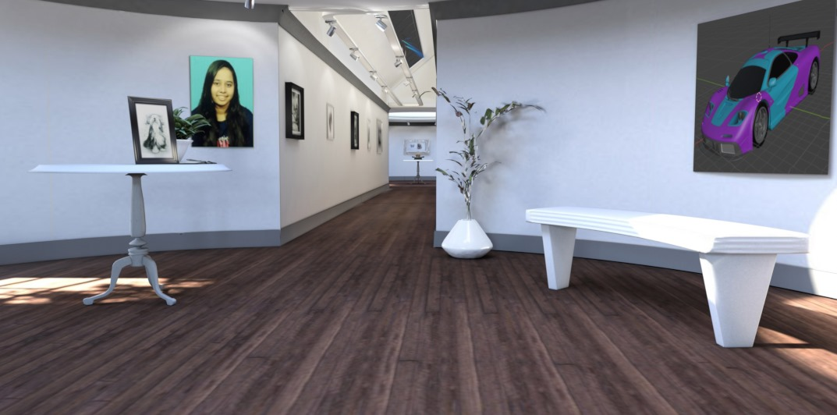

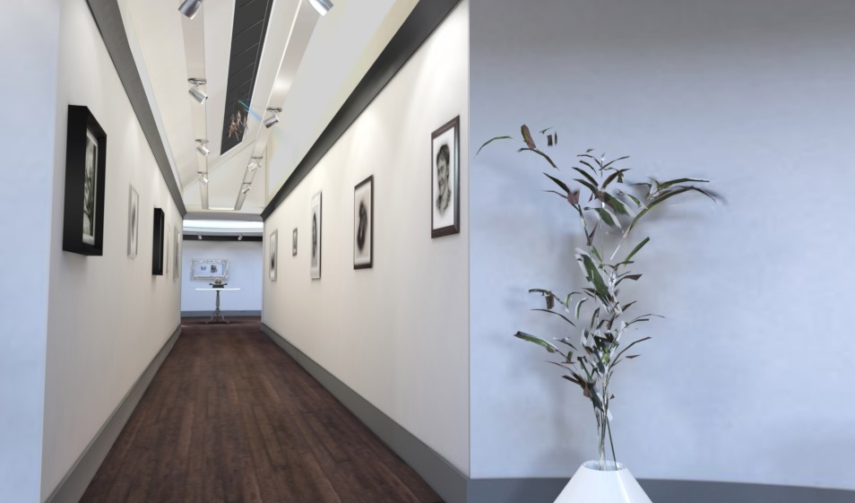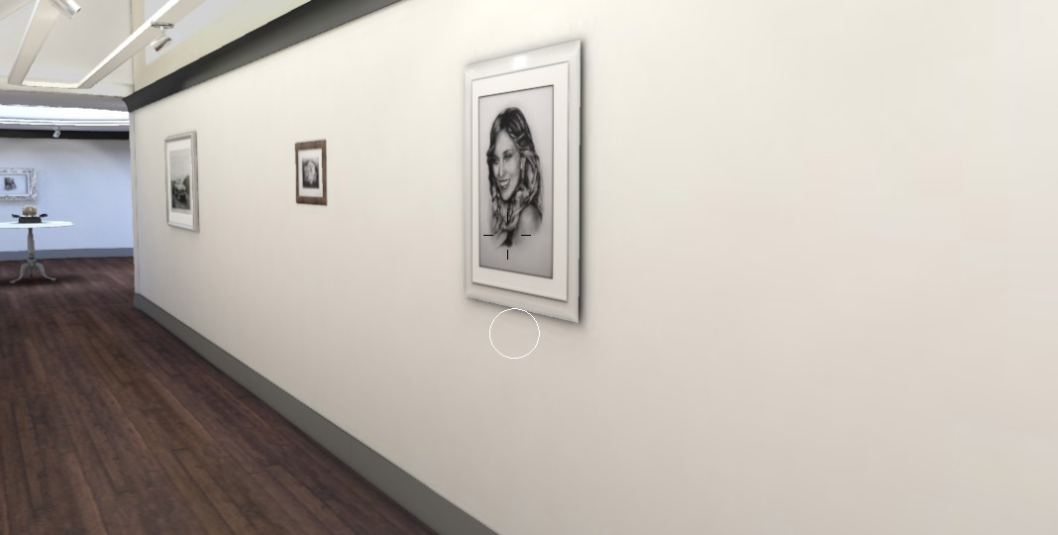

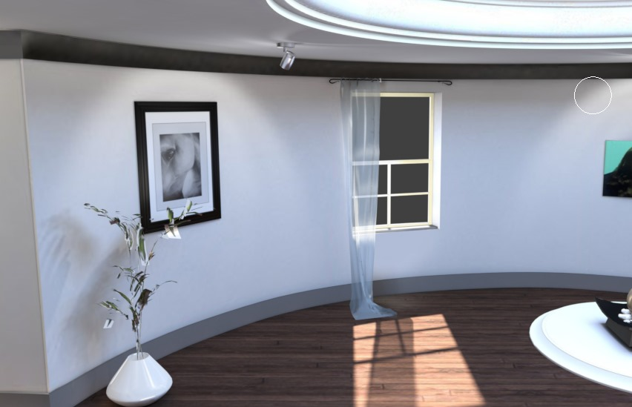

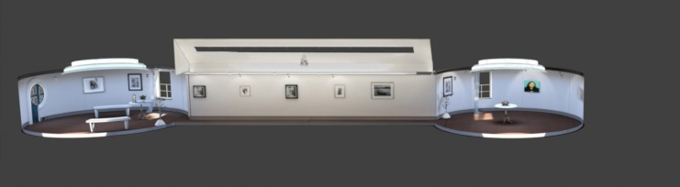

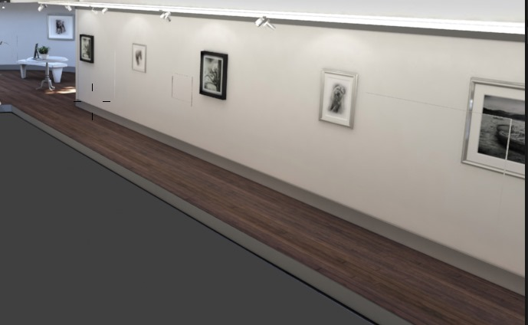

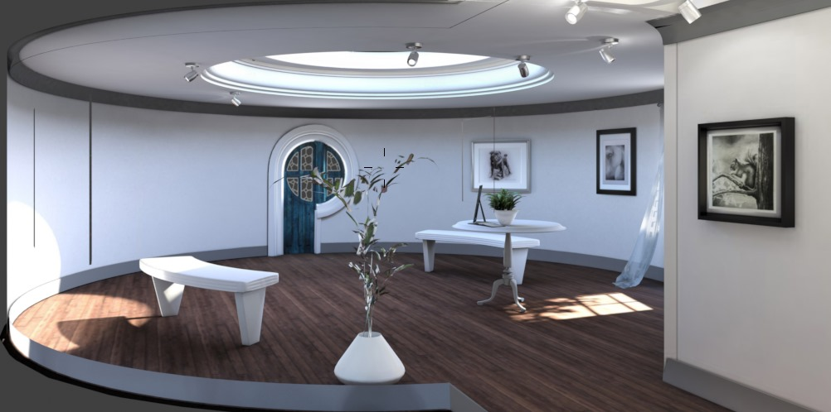

# Chapter 5 Conclusion and Further Work

### Conclusion and Discussion

The **AR Art Gallery project** successfully showcases the transformative power of **Augmented Reality (AR)** in delivering a fully immersive, engaging art experience. By combining **Blender** for high-quality 3D modeling with an **AR SDK for spatial mapping and interaction**, we have created a virtual gallery environment that allows users to explore and interact with digital artworks as though they were physically present. The project overcomes the traditional limitations of physical galleries by enabling users to experience art in any environment, creating a personalized connection with each piece.

Through this project, we have demonstrated how AR technology can redefine art exhibitions, opening new pathways for virtual art galleries, educational experiences, and more. This innovative approach to art curation not only broadens access but also emphasizes AR’s potential to revolutionize digital art spaces, making art more accessible, interactive, and impactful.

### Scope for Future Work

While the AR Art Gallery lays a strong foundation, there are numerous potential enhancements and expansions that could elevate the project to new heights. Future development efforts could focus on:

* **Advanced Lighting and Shading:**
  + Incorporating real-time lighting adjustments that respond to changes in the surrounding environment, such as ambient lighting or shadows. This would greatly enhance realism, making the artworks appear seamlessly integrated into any physical space.
  + Adding adaptive shading and dynamic reflections to further improve the visual fidelity, allowing digital pieces to react to the user’s environment in real-time.
* **Expanded Art Collection:**
  + Extending the gallery’s variety of art pieces by adding **3D sculptures**, **animated works**, and **interactive digital art** to enrich the experience and attract a diverse audience.
  + Including different artistic mediums and genres, such as contemporary digital art, historical reproductions, and experimental AR-specific artworks, which would broaden the gallery’s appeal and educational value.
* **Enhanced User Interaction:**
  + Developing additional user interactions, such as the ability to "like" or save favorite pieces, add comments, or share experiences on social media. This would allow users to personalize their experience, fostering a deeper connection with the art.
  + Adding features such as **gesture-based controls** and **voice commands** to make the experience even more intuitive and accessible.
* **Multi-User AR Experience:**
  + Enabling a **multi-user AR environment** where multiple users can simultaneously view, explore, and interact with the gallery. This would support collaborative experiences, allowing users to discuss and explore art together in real-time.
  + Implementing shared interactions or co-exploration features, such as leaving virtual comments for others to read, or “curating” favorite pieces as a group, would further enrich the social aspect of the virtual gallery.

These potential advancements illustrate the AR Art Gallery’s capacity for growth and evolution, underscoring its role as a pioneering project in the field of digital and interactive art. By continuing to enhance realism, interactivity, and social engagement, future versions of the AR Art Gallery could provide an even more dynamic and engaging experience for users worldwide.

### Bibliography

* Kushner, David. *Masters of Doom: How Two Guys Created an Empire and Transformed Pop Culture*. Random House, 2003.
* "Wolfenstein 3D Developer Postmortem." *Gamasutra*.

### Acknowledgements

I extend my sincere gratitude to our esteemed Prof. Vaibhav Vasani for his invaluable guidance and unwavering support throughout the duration of this project. His expertise and mentorship played a pivotal role in steering us towards success and ensuring that our project met the highest standards of excellence. His dedication to our learning and development empowered us to overcome challenges and achieve our goals effectively.

Furthermore, I am deeply thankful to him for entrusting us with the opportunity to work on this remarkable project. It has been an enriching experience for all of us, providing invaluable insights into the intricacies of web and software development. Under his guidance, we were able to explore new technologies, refine our skills, and broaden our understanding of the subject matter.

I express my heartfelt appreciation to Prof. Vaibhav Vasani for his outstanding mentorship, encouragement, and belief in our capabilities. This project has not only enhanced our academic learning but has also equipped us with valuable skills and experiences that will undoubtedly benefit us in our future endeavors.